Educating teachers…educating young Australians for the 21st century
A statement on national curriculum from the national peak professional associations in English (Australian Association for the Teaching of English; AATE), History (History Teachers Association of Australia; HTAA), Mathematics (Australian Association of Mathematics Teachers; AAMT) and Science (Australian Science Teachers Association; ASTA)

Preamble
We endorse a national K-12 curriculum that supports teachers in meeting the needs of students into the future. Development of a national curriculum should be positive and forward-looking, based on findings of current research. It should contribute to nation-building and Australia’s long term social and economic prosperity in ways that acknowledge, harness and extend the creative potential of diversity.
But development of any curriculum cannot occur in isolation. In concert with a focus on the developmentof a national curriculum, substantial effort and resources need to be applied to addressing other pressing needs in Australian education. These include attracting and retaining well-prepared teachers; supporting teachers’ professional work by providing extensive and high quality professional learning for teachers, and by developing and providing access to high quality teaching resources and technologies; and addressing the under-achievement of identifiable groups of students.
To be successful, this national initiative needs to have not only the input from, but also the ownership of the professional educators that will be charged with its implementation. The necessity of professional input to, and ownership of this program requires the direct engagement of teachers and other educators at all stages of its development and implementation.

Principles
A national curriculum should
- Be forward-looking whilst also valuing existing successful practices
- Be written for teachers, in consultation with teachers
- Support professional decision-making at the classroom level
- Allow flexibility to enable teachers to address the needs of their students
- Promote teaching practices that engage and challenge students
- Balance the following elements of authentic learning: the acquisition of knowledge, skills development, application, innovation and creativity

Recommendations
The National Curriculum Board should ensure that:
- The relevant subject associations have access to the Board in order to provide input throughout all stages of the process
- Writing groups are expertise based, with representation that includes teachers and academics
- Subject associations have representatives on expert writing groups
- Involvement of teachers in consultation must be adequately funded
- Teacher educators are kept aware of and involved in all aspects of the Board’s work
- Ongoing evaluation and renewal of the national curriculum is built into the medium and long term

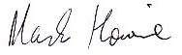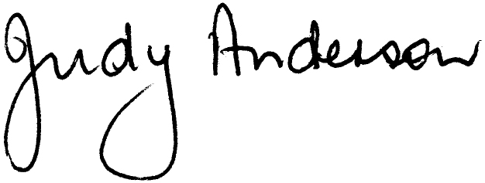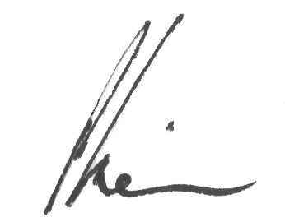

Mr Mark Howie Dr Judy Anderson Mr Peter Turnbull Mr Paul Kiem
President AATE President AAMT President ASTA President HTAA

